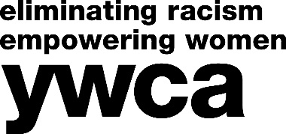
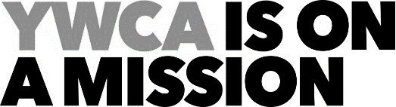

EVENTS/DEVELOPMENT INTERN
(Fall, Spring, Summer Semesters)

DESCRIPTION
This internship will assist the Events Coordinator in some or all of the following areas, dependent on the applicant’s experience, skills, and course of study: event planning, community relations, donor relationships, sponsorships, donor information management and event research.

ESSENTIAL DUTIES AND RESPONSIBILITIES:
- Assist with creation of event proposals
- Conduct research for potential sponsors and donors for events
- Create and manage event timelines and schedules
- Attend planning meetings and trainings as assigned
- Manage volunteer recruitment, sign-up and training
- Collaborate with event committees, chairpersons and teams to implement event goals
- Initiate and maintain relationships with local business vendors for event related resources
- Assist in the management of the donor information database which may include: entering confidential donor information into the databases; organizing data and creating reports
- Act as an onsite resource during events and assist the Events Coordinator and event volunteers with all aspects of the event.
- Other duties assigned.

REQUIREMENTS
- Coursework at a college junior and senior level preferred in public relations, event planning, communications, computer science, or related field
- Strong verbal and written communication skills required
- Multi-tasking skills necessary
- Some background in computer software preferred
- Proficiency in English required
TO APPLY:

Submit a resume, cover letter, writing samples, and YWCA intern application to Human Resources. Applications can be downloaded: www.ywcamclean.org

Human Resources
YWCA McLean County
1201 N Hershey Road
Bloomington, IL 61704
Email: ywcajobs@ywcamclean.org

YWCA is dedicated to eliminating racism, empowering women and promoting peace, justice, freedom and dignity for all.

YWCA McLean County is an equal employment opportunity employer.

