Illinois State University
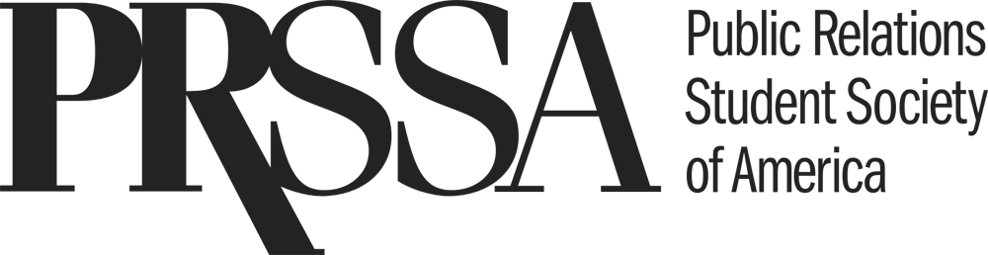

Social Media Request Form

Please fill out all elements below and submit to the Historian (Abigail Brennan) via prssa@ilstu.edu AT LEAST 48 HOURS BEFORE DESIRED POST TIME.

Please note not all requests will be posted. The Historian and ISU PRSSA Executive Board have final approval on submissions.

Member Making Request:

E-mail address:

Target Audience:

Message:

Social Media Platform (Facebook, Twitter, Instagram, LinkedIn):

Post time:

Please attach any relevant links or media (i.e. photos or other graphics).

